Questions:
Paper Work:
1- Find the mean and standard deviation of A.
A = {9,10,11,7,13, 7,4,11,13,10}
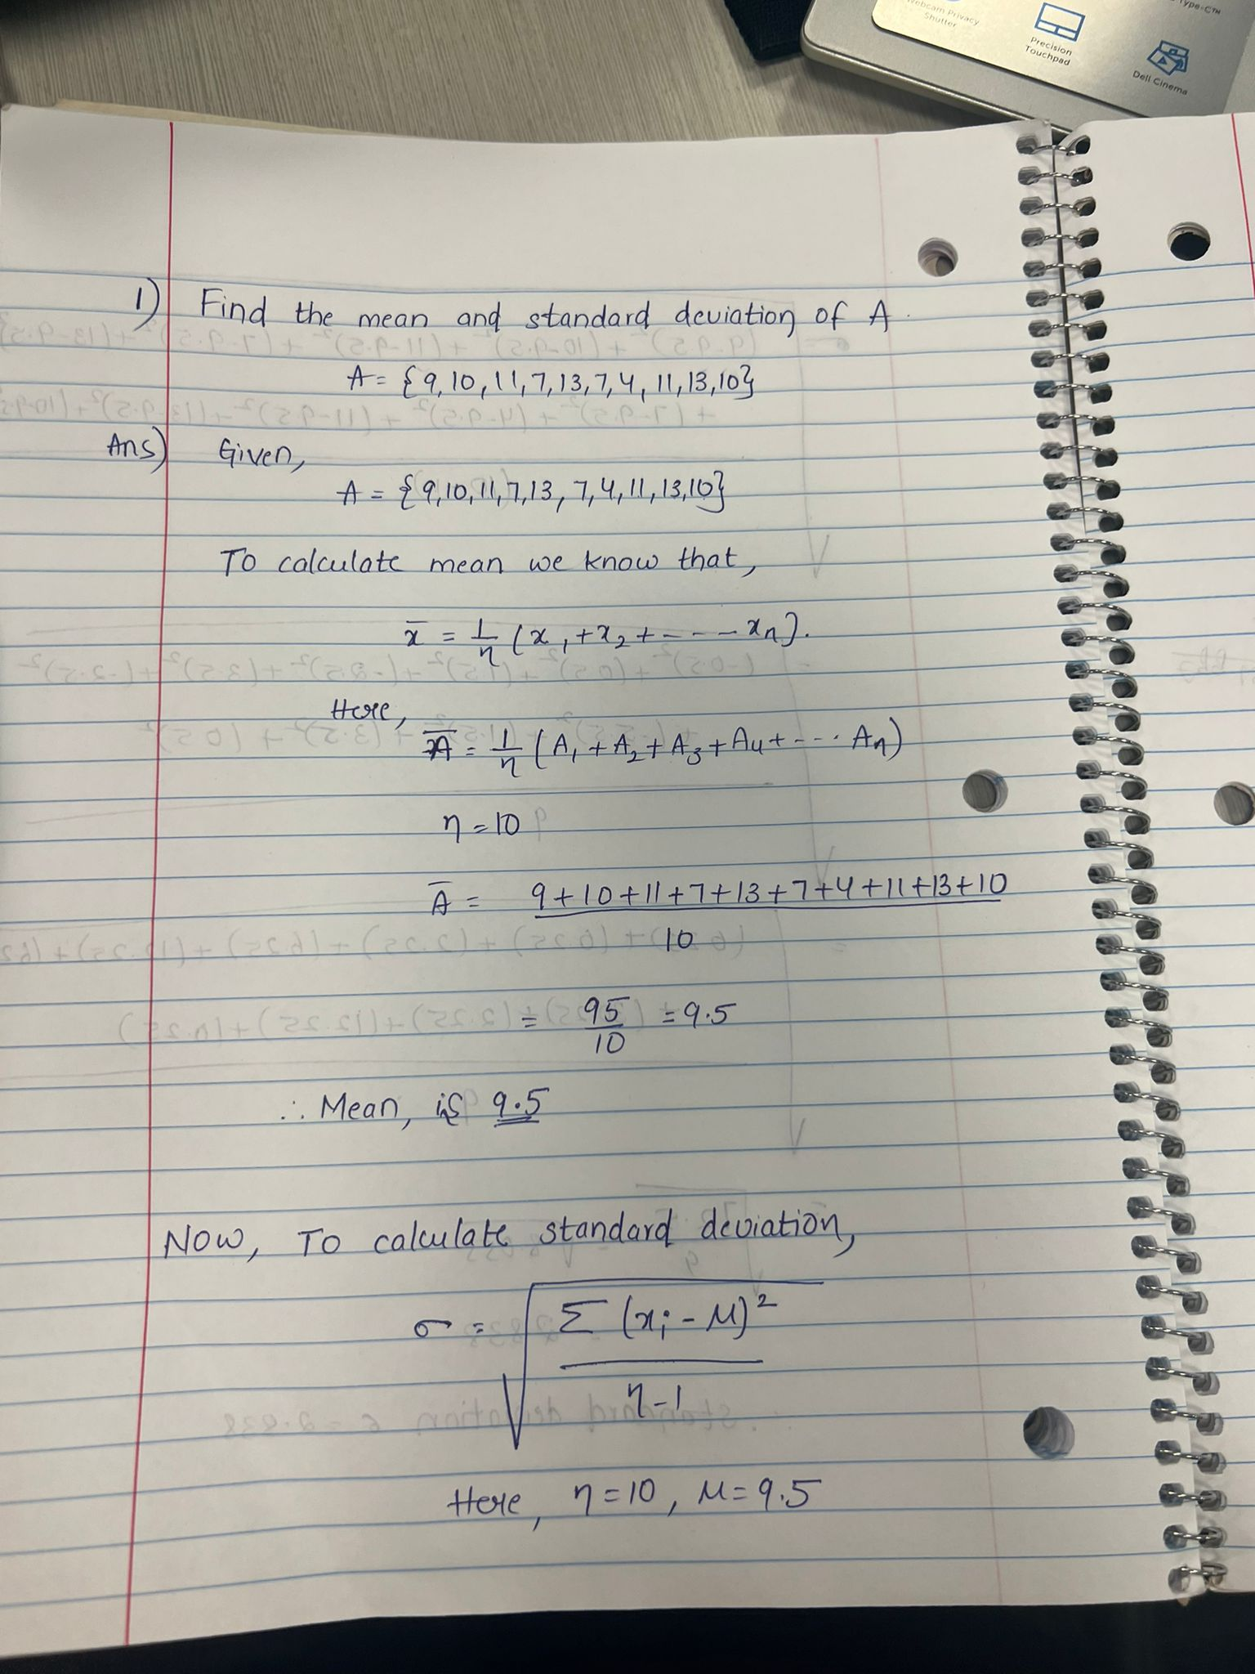
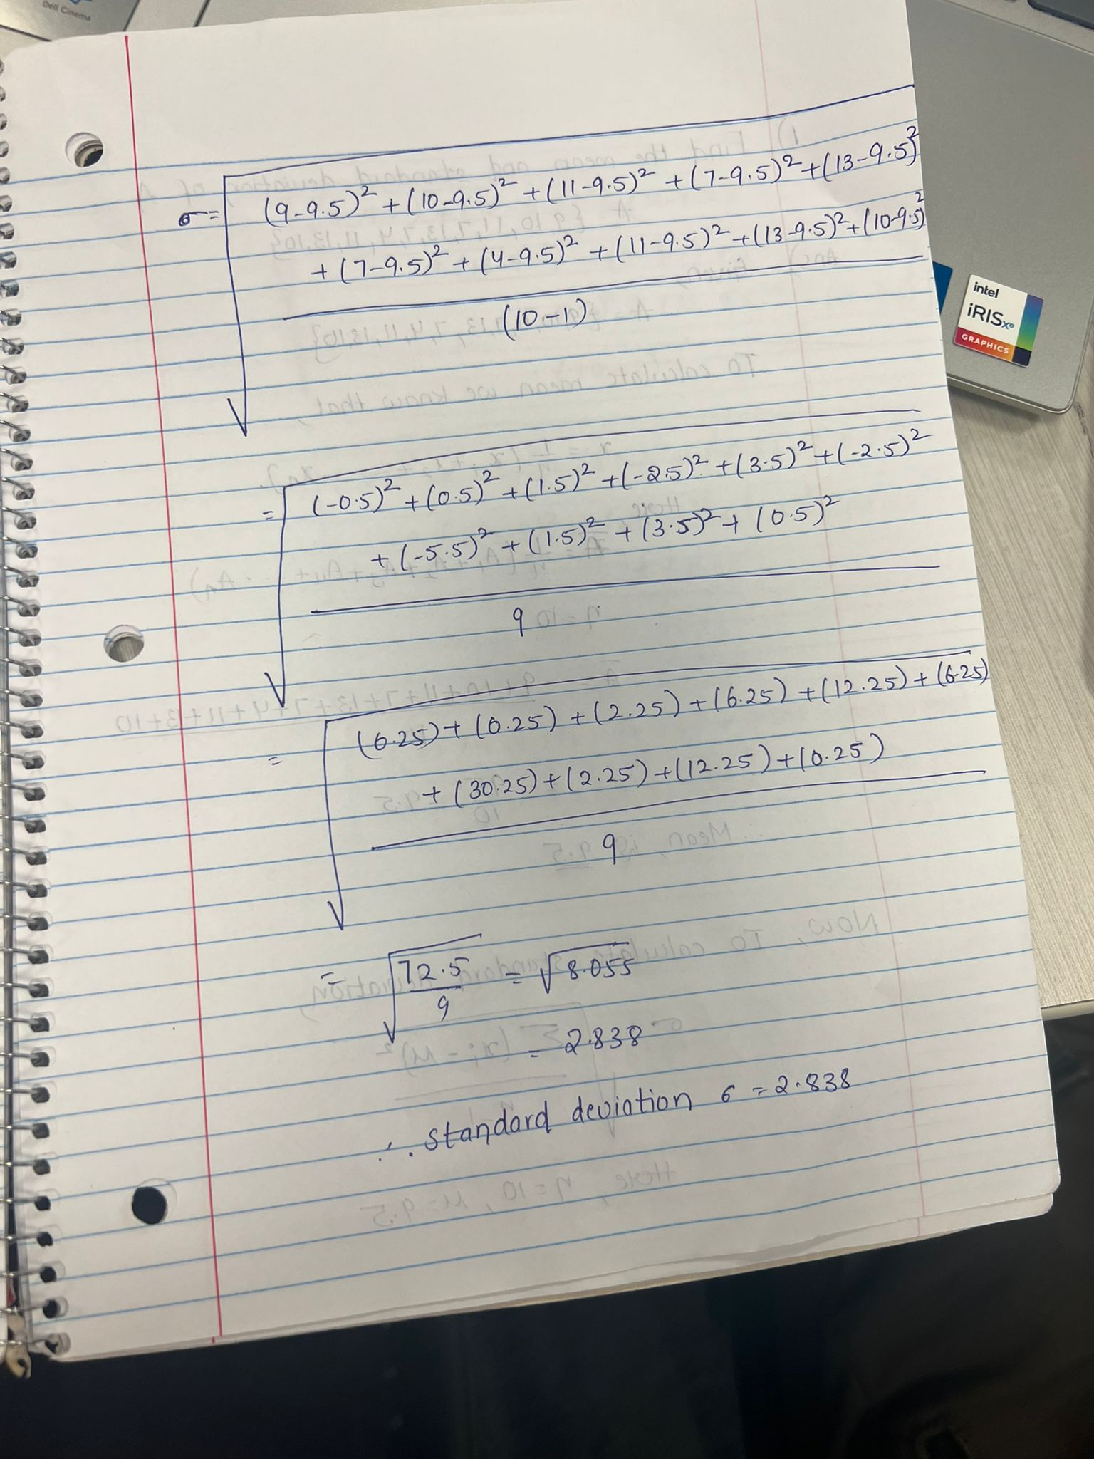

Python Work:
3- Write a code in Python:
- Enter vector A of question 1 in Python. Copy the code. (Hint: A<- c(2,4,…))
- Find the mean and standard deviation of A. Copy the code.
- Do your results match question 1?

import statistics
# Define data vector A
A = [9, 10, 11, 7, 13, 7, 4, 11, 13, 10]
# Calculate the mean
mean_A = statistics.mean(A)
# Print the mean
print("Mean of A is %s" % mean_A)
# Calculate the standard deviation
std_deviation_A = statistics.stdev(A)
# Print the standard deviation
print("Standard Deviation of A is %s" % std_deviation_A)

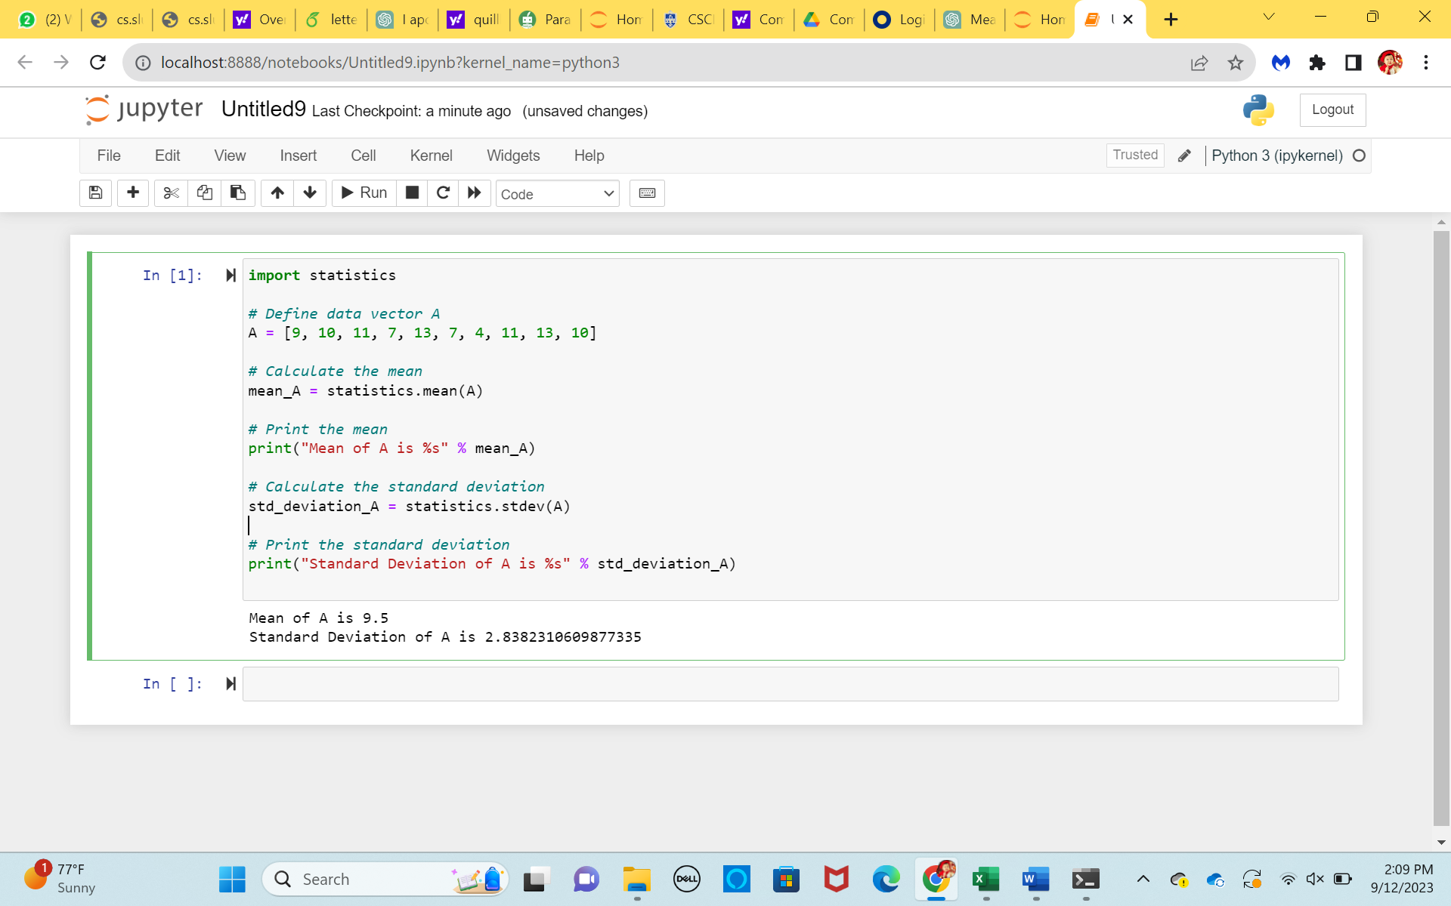

Yes the results of mean and standard deviation match question 1.

